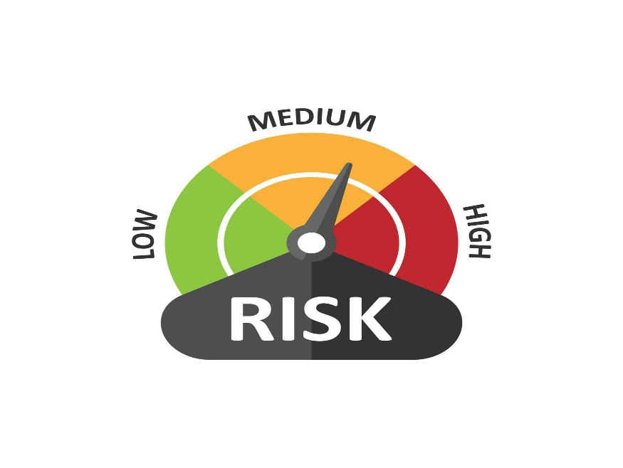
Financial Institution MITRE ATT&CK Framework Analysis

Goal of Research
- Identify APT groups that may pose risk to XX Organisation
- Focus on APT groups that fall under financial and government industry
- Research the TTPs used by APT groups
- Conduct analysis of ##Financial Institution’s capabilities to defend against APT group TTPs

Financial APT Group Analys
Researching Financial APT Groups

We started our research off of the APT group database found on the MITRE ATT&CK navigator. From here, we started to filter the APT groups based on if they pose risk to the financial sector. In order to be more efficient in the filtering process, we decided to only worry about APT groups that attacked/attacks the USA.

After this initial research/filter phase, we had 41 APT Groups that had a history of targeting the financial sector.

With this narrowed down list of APT groups, we went through each one and researched things such as:
1) What type of attacks have they done in the past?
2) What specific type of financial institution did the APT group attack?
3) How sophisticated and capable are these APT groups?

Based on these questions, we assigned a “Danger Score” ranging from 1(No Risk) to 5(High Risk) to each of the APT groups. If an APT group specifically attacked banks or credit unions, they were granted a 5. We selected the top 7 APT groups that had the highest scores and posed the most risk to XX Organization based on their past attacks and sophistication.

The groups were:
Scattered Spider, APT1, Indrik Spider, Carbanak, Cobalt Group, Dark Vishnya, Lazarus Group
Utilizing MITRE ATT&CK Navigator
After we had our 8 groups, we put those APT groups into the MITRE ATT&CK Navigator which shows a dashboard of all the TTPs that these APT groups use.
TTPs that are in a shade of red came up more than the TTPs that are in a shade of green. Therefore, red TTPs are those that should be of more concern.

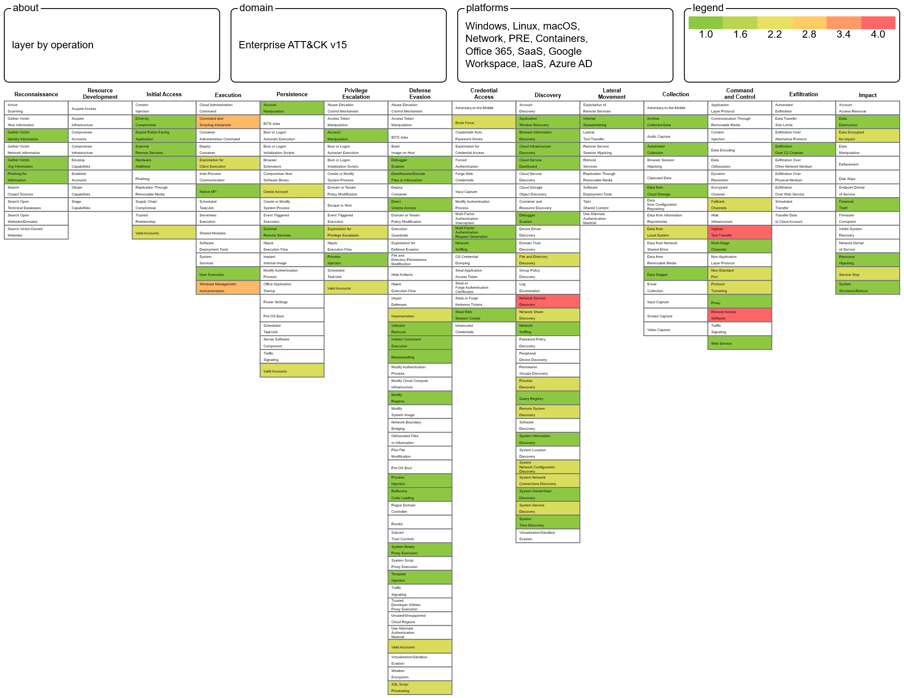
Financial Critical TTPs
Resource Development / Obtain Capabilities / Tool
Execution / Command and Scripting Interpreter / PowerShell
Execution / Command and Scripting Interpreter / Windows Command Shell
Persistence / Create or Modify System Process / Windows Service
Privilege Escalation / Create or Modify System Process / Windows Service
Defense Evasion / Masquerading / Match legitimate name or location
Discovery / Network Service Discovery
Command and Control / Ingress Tool Transfer
Command and Control / Remote Access Software

Resource Development / Obtain Capabilities / Tool

APT Groups
Lazarus, Dark Vishnya, Cobalt Group, Carbanak, APT1, Scattered Spider

MITRE Description
Adversaries may buy, steal, or download software tools that can be used during targeting. Tools can be open or closed source, free or commercial. A tool can be used for malicious purposes by an adversary, but (unlike malware) were not intended to be used for those purposes

Dangers
Utilizing tools in order to carry out malicious attacks. Attackers who are not that sophisticated could cause damage due to these available tools

XX Organization’s Capabilities Against TTP
Hard to mitigate the availability of tools as XX Organization has no control over that. XX Organization employs a layered defense system in order to defend against any tool or malicious attack.

Execution / Command and Scripting Interpreter / PowerShell

APT Groups
Lazarus, Indrik Spider, Cobalt Group, Dark Vishnya

MITRE Description
Adversaries may abuse PowerShell commands and scripts for execution. PowerShell is a powerful interactive command-line interface and scripting environment included in the Windows operating system.^{[1]} Adversaries can use PowerShell to perform a number of actions, including discovery of information and execution of code.

Dangers
Utilizing PowerShell to execute harmful scripts/commands for data exfiltration, lateral movement, ransomware deployment, disabling security controls

XX Organization’s Capabilities against TTP
- Application whitelisting: Allow only approved scripts and executables to run
- Network Segmentation: Isolate critical systems
- Log scripts: Constantly monitor for any suspicious activity
- Least Privilege: Assign minimal permissions to user accounts, avoid running PowerShell unless necessary

Execution / Command and Scripting Interpreter / Windows Command Shell

APT Groups
Lazarus, Cobalt Group, Indrik Spider, APT1

MITRE Definition
Adversaries may abuse the Windows command shell for execution. The Windows command shell (cmd) is the primary command prompt on Windows systems. The Windows command prompt can be used to control almost any aspect of a system, with various permission levels required for different subsets of commands.

Dangers
Utilizing Windows Command Shell to execute malicious code for lateral movement, data exfiltration, disabling security controls, ransomware deployment

XX Organization’s Capabilities against TTP
- Application Whitelisting: Allow only approved scripts and executables to run
- Network Segmentation: Isolate critical systems
- Log scripts: Constantly monitor logs for any suspicious activity
- Least Privilege: Assign minimal permissions to user accounts, disable unused Windows CS features

Persistence / Create or Modify System Process / Windows Service

APT Groups
Lazarus, Dark Vishnya, Cobalt Group, Carbanak

MITRE Definition
Adversaries may create or modify Windows services to repeatedly execute malicious payloads as part of persistence. When Windows boots up, it starts programs or applications called services that perform background system functions.^{[1]} Windows service configuration information, including the file path to the service's executable or recovery programs/commands, is stored in the Windows Registry.

Dangers
Create/modify Windows services to run in the background, masquerading as legitimate services

XX Organization’s Capabilities against TTP
- Application whitelisting: Only allow approved services to run
- Security Hardening: Review and audit existing services
- Patching: Keep operating system and services up to date as vulnerabilities can lead to exploitation

Defense Evasion / Masquerading / Match legitimate name or location

APT Groups
Lazarus, Carbanak, Indrik Spider, APT1,

MITRE Definition
Adversaries may match or approximate the name or location of legitimate files or resources when naming/placing them. This is done for the sake of evading defenses and observation. This may be done by placing an executable in a commonly trusted directory (ex: under System32) or giving it the name of a legitimate, trusted program (ex: svchost.exe). In containerized environments, this may also be done by creating a resource in a namespace that matches the naming convention of a container pod or cluster. Alternatively, a file or container image name given may be a close approximation to legitimate programs/images or something innocuous.

Dangers
Evade defenses and detection by matching name/location of legitimate files/resources that can lead to undetected malware, execution of malware, and spread of malware

XX Organization’s Capabilities against TTP
- File Integrity Monitoring: Monitor changes to critical system files and directories
- Employee Training: Train to verify file sources and avoid blindly executing files
- Regular Audits: Review directories and services, remove suspicious/unnecessary entries
- Endpoint Detection: Signature-based detection, behavioral analysis, and heuristic algorithms to protect against malicious files and executables

Discovery / Network Service Discovery

APT Groups
Scattered Spider, Cobalt Group, Dark Vishnya, Lazarus

MITRE Definition
Adversaries may attempt to get a listing of services running on remote hosts and local network infrastructure devices, including those that may be vulnerable to remote software exploitation. Common methods to acquire this information include port and/or vulnerability scans using tools that are brought onto a system.

Dangers
While devices perform network discovery, data can be intercepted by third parties, malicious software with network access can read all unencrypted traffic, and devices may have exploitable vulnerabilities

XX Organization’s Capabilities against TTP
- Network Segmentation: Isolate critical systems to limit exposure during discovery
- Firewalls: Configure firewalls and rules to restrict unnecessary service discovery traffic
- Encryption: Encrypt traffic to prevent eavesdropping
- Authentication and Authorization: Authenticate and ensure only authorized devices are participating in network discovery

Command and Control / Ingress Tool Transfer

APT Groups
Scattered Spider, Indrik Spider, Cobalt Group, Lazarus

MITRE Definition:
Adversaries may transfer tools or other files from an external system into a compromised environment. Tools or files may be copied from an external adversary-controlled system to the victim network through the command and control channel or through alternate protocols such as ftp. Once present, adversaries may also transfer/spread tools between victim devices within a compromised environment

Dangers
Transfer tools/files to compromised environment in order to move laterally within network for malware delivery

XX Organization’s Capabilities against TTP
- Network Segmentation: Isolate critical systems to prevent lateral movement
- Firewall Rules: Configure firewalls to restrict tool transfer traffic
- Least Privilege: Ensure only authorized users can transfer tools
- Monitoring and Detection: IDS and IPS to detect any suspicious tool transfers, utilizing signatures

Command and Control / Remote Access Software

APT Groups
Scattered Spider, Carbanak, Cobalt Group, Dark Vishnya

MITRE Definition:
An adversary may use legitimate desktop support and remote access software to establish an interactive command and control channel to target systems within networks. These services, such as VNC, Team Viewer, AnyDesk, ScreenConnect, LogMein, AmmyyAdmin, and other remote monitoring and management (RMM) tools, are commonly used as legitimate technical support software and may be allowed by application control within a target environment.

Dangers
Attackers may use command and control to remotely manage compromised systems, carrying out malicious activities undetected

XX Organization’s Capabilities against TTP
- Network Segmentation: Isolate critical systems so they are not be access by lateral movement
- Credentials: Implement strong password policies, MFA, and regular password changes to prevent account access
- Remote Access Control: Restrict remote access to essential personnel, use secure VPNs
- Logging: Continuously monitor logs for any unauthorized behavior or suspicious activity

Government APT Group Analysis

Researching Government APT Groups

We started our research off of the APT group database found on the MITRE ATT&CK navigator. From here, we started to filter the APT groups based on if they pose risk to the Government sector. In order to be more efficient in the filtering process, we decided to only worry about APT groups that attacked/attacks the USA.

After this initial research/filter phase, we had 31 APT Groups that had a history of targeting the Government sector.

With this narrowed down list of APT groups, we went through each one and researched things such as:
1) What type of attacks have they done in the past
2) What specific type of US government body did they attack?
3) How sophisticated and capable are these APT groups?

Based on these questions, we assigned a “Danger Score” ranging from 1(No Risk) to 5(High Risk) to each of the APT groups. APT groups that attacked important government bodies (ex. Department of Defense, Pentagon, White House) were awarded a score of 5. We selected the top 6 APT groups that had the highest scores and posed the most risk to XX Organization based on their past attacks and sophistication.

The groups were:
APT41, APT19, Sofacy, Turla, APT29, APT33

Utilizing MITRE ATT&CK Navigator
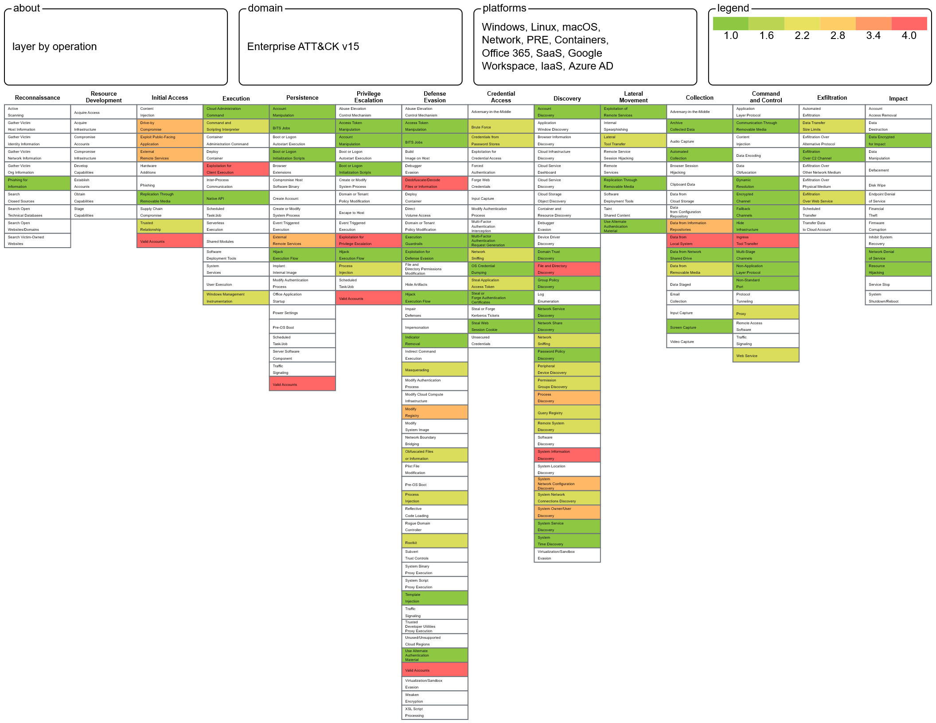
After we had our 6 groups, we put those APT groups into the MITRE ATT&CK Navigator which shows a dashboard of all the TTPs that these APT groups use. TTPs that are in a shade of red came up more than the TTPs that are in a shade of green. Therefore, red TTPs are those that should be of more concern.

Government Critical TTPs
Resource Development / Obtain Capabilities / Tool
Initial Access / Phishing / Spear phishing Attachment
Execution / Command and Scripting Interpreter / PowerShell
Persistence / Boot or Logon AutoStart Execution / Registry Run Keys Startup Folder
Privilege Escalation / Exploitation for Privilege Escalation
Defense Evasion / Obfuscate or Decode Files of Information
Discovery / System Information Discovery
Collection / Archive Collected Data/ Archive via Utility
Command and Control / Application Layer Protocol / Web Protocols
Command and Control / Ingress Tool Transfer

Resource Development / Obtain Capabilities / Tool

APT Groups
APT41, APT19, Sofacy, Turla, APT29, APT33

MITRE Description
Adversaries may buy, steal, or download software tools that can be used during targeting. Tools can be open or closed source, free or commercial. A tool can be used for malicious purposes by an adversary, but (unlike malware) were not intended to be used for those purposes

Dangers
Utilizing tools in order to carry out malicious attacks. Attackers who are not that sophisticated could cause damage due to these available tools

XX Organization’s Capabilities Against TTP
Hard to mitigate the availability of tools as XX Organization has no control over that. XX Organization employs a layered defense system in order to defend against any tool or malicious attack.

Initial Access / Phishing / Spear phishing Attachment

APT Groups
APT41, APT19, Sofacy, Turla, APT29, APT33

MITRE Description
Adversaries may send spearphishing emails with a malicious attachment in an attempt to gain access to victim systems. Spearphishing attachment is a specific variant of spearphishing. Spearphishing attachment is different from other forms of spearphishing in that it employs the use of malware attached to an email. All forms of spearphishing are electronically delivered social engineering targeted at a specific individual, company, or industry. In this scenario, adversaries attach a file to the spearphishing email and usually rely upon User Execution to gain execution.^{[1]} Spearphishing may also involve social engineering techniques, such as posing as a trusted source.

Dangers
Targeted attacks to deceive a particular individual with attachments that contain malware, disguised executables in order to commit malicious activities

XX Organization’s Capabilities Against TTP
- Employee Training: PhishER used to train employees on social engineering attacks such as phishing
- Network Intrusion Prevention: Scan and remove malicious email attachments
- Restricting Content: Block risky attachments
- Antivirus: Scan for viruses

Execution / Command and Scripting Interpreter / PowerShell

APT Groups
APT33, APT29, Turla, Sofacy, APT19, APT41

MITRE Description
Adversaries may abuse PowerShell commands and scripts for execution. PowerShell is a powerful interactive command-line interface and scripting environment included in the Windows operating system.^{[1]} Adversaries can use PowerShell to perform a number of actions, including discovery of information and execution of code.

Dangers
Utilizing PowerShell to execute harmful scripts/commands for data exfiltration, lateral movement, ransomware deployment, disabling security controls

XX Organization’s Capabilities against TTP
- Application whitelisting: Allow only approved scripts and executables to run
- Network Segmentation: Isolate critical systems
- Log scripts: Constantly monitor for any suspicious activity
- Least Privilege: Assign minimal permissions to user accounts, avoid running PowerShell unless necessary

Persistence / Boot or Logon AutoStart Execution / Registry Run Keys Startup Folder

APT Groups
APT41, APT19, APT33, APT29, Turla, Sofacy

MITRE Description
Adversaries may achieve persistence by adding a program to a startup folder or referencing it with a Registry run key. Adding an entry to the "run keys" in the Registry or startup folder will cause the program referenced to be executed when a user logs in.^{[1]} These programs will be executed under the context of the user and will have the account's associated permissions level.

Dangers
Executing programs unknown to user can lead to malware persistence, system performance impact, increased attack surface

XX Organization’s Capabilities against TTP
- Application whitelisting: Allow only approved programs and executables to run
- Monitor: Monitor executed commands, start folder, newly created registry keys for any suspicious or unauthorized behavior

Privilege Escalation / Exploitation for Privilege Escalation

APT Groups
APT41, APT33, APT29, Turla, Sofacy

MITRE Description
Adversaries may exploit software vulnerabilities in an attempt to elevate privileges. Exploitation of a software vulnerability occurs when an adversary takes advantage of a programming error in a program, service, or within the operating system software or kernel itself to execute adversary-controlled code. Security constructs such as permission levels will often hinder access to information and use of certain techniques, so adversaries will likely need to perform privilege escalation to include use of software exploitation to circumvent those restrictions.

Dangers
With privilege escalation, attackers gain more access to critical systems and can cause great damage by installing malware, deleting databases, disabling crucial services, and stealing sensitive files

XX Organization’s Capabilities against TTP
- Isolation and Sandboxing: Make it difficult for attackers to advance their operation
- Execution Prevention: Block execution of known vulnerability drivers that attackers may exploit
- Exploit Protection: Security applications that analyze behavior during exploits can be used to mitigate
- Updates: Employ patches and updates to mitigate vulnerabilities

Defense Evasion / Obfuscate or Decode Files of Information

APT Groups
APT41, APT19, APT29, Turla, Sofacy

MITRE Description
Adversaries may use Obfuscated Files or Information to hide artifacts of an intrusion from analysis. They may require separate mechanisms to decode or deobfuscate that information depending on how they intend to use it. Methods for doing that include built-in functionality of malware or by using utilities present on the system.

Dangers
Obfuscating files to evade defenses could lead to attackers being in your system undetected

XX Organization’s Capabilities against TTP
- Monitor: Monitor changes made to files, newly executed processes, and scripts as these changes may be used to hide artifacts
- EDR: Analyze and detect anomalies indicative of obfuscation techniques
- Signature Based Detection and Heuristics: Recognize patterns and behaviors of previous obfuscations and utilize heuristics to detect variations in methods

Discovery / System Information Discovery

APT Groups
APT41, APT19, APT29, Turla, Sofacy

MITRE Description
An adversary may attempt to get detailed information about the operating system and hardware, including version, patches, hotfixes, service packs, and architecture. Adversaries may use the information from System Information Discovery during automated discovery to shape follow-on behaviors, including whether or not the adversary fully infects the target and/or attempts specific actions.

Dangers
Attackers could gain detailed information about the security posture of an organization and develop specific attacks

XX Organization’s Capabilities against TTP
- Encryption: Encrypt sensitive data to prevent attackers from gaining knowledge
- Network Segmentation: Isolate critical systems and sensitive data to reduce possible exposure
- Monitor: Review logs for any suspicious activity

Collection / Archive Collected Data/ Archive via Utility

APT Groups
APT41, APT33, APT29, Turla, Sofacy

MITRE Description
Adversaries may use utilities to compress and/or encrypt collected data prior to exfiltration. Many utilities include functionalities to compress, encrypt, or otherwise package data into a format that is easier/more secure to transport. Adversaries may abuse various utilities to compress or encrypt data before exfiltration. Some third party utilities may be preinstalled, such as tar on Linux and macOS or zip on Windows systems.

Dangers
By using utilities to encrypt data prior to exfiltration, attackers can go undetected and an organization may not even know data is being exfiltrated

XX Organization’s Capabilities against TTP
- Audit: System scans can be performed to identify unauthorized archived utilities
- Application Whitelisting: restrict use of utilities to prevent unauthorized/unknown utilities from running
- EDR: Provide visibility into endpoint activities like data compression/encryption

Command and Control / Application Layer Protocol / Web Protocols

APT Groups
APT41, APT33, APT29, Turla, Sofacy, APT19

MITRE Description
Adversaries may communicate using application layer protocols associated with web traffic to avoid detection/network filtering by blending in with existing traffic. Commands to the remote system, and often the results of those commands, will be embedded within the protocol traffic between the client and server.

Dangers
Attackers can go undetected and perform malicious attacks from within

XX Organization’s Capabilities against TTP
- Packet Inspection: Implementing DPI to analyze web traffic to look for anomalies
- Network Segmentation and Access Control: Isolating critical assets and ensure only authorized traffic and protocols are permitted, reducing attack surface
- SSL/TLS Inspection: Many communications may be encrypted with SSL/TLS, so inspecting may uncover malicious activities hidden within

Command and Control / Ingress Tool Transfer

APT Groups
APT41, APT33, APT29, Turla, Sofacy

MITRE Definition:
Adversaries may transfer tools or other files from an external system into a compromised environment. Tools or files may be copied from an external adversary-controlled system to the victim network through the command and control channel or through alternate protocols such as ftp. Once present, adversaries may also transfer/spread tools between victim devices within a compromised environment

Dangers
Transfer tools/files to compromised environment in order to move laterally within network for malware delivery

XX Organization’s Capabilities against TTP
- Network Segmentation: Isolate critical systems to prevent lateral movement
- Firewall Rules: Configure firewalls to restrict tool transfer traffic
- Least Privilege: Ensure only authorized users can transfer tools
- Monitoring and Detection: IDS and IPS to detect any suspicious tool transfers, utilizing signatures

